**Assignment 01 SBA301 - Working with ReactJS application**

# 1. Introduction

A News Management System (NMS) is a software application that helps universities and educational institutions to efficiently manage, organize, and publish news and content to their website and other channels. The NMS typically includes features such as content creation, approval workflow, scheduling, publishing, and analytics. This can help universities to arrange appropriately their news operations, improve communication with students and the wider community, and better engage with their target audience.

Imagine you're a developer of a News Management System named **FUNewsManagementSystem**. To implement a part of this system your tasks include:

* Manage account information.
* Manage news article.

The application has to support adding, viewing, modifying, and removing information - a  
standardized usage action verb better known as Create, Read, Update, Delete (CRUD) and Search.  
*This assignment explores*

* Create a back-end website using ReactJS based on an available HTML template.
* Create components to build a master page (layout) for the backend website.

Example

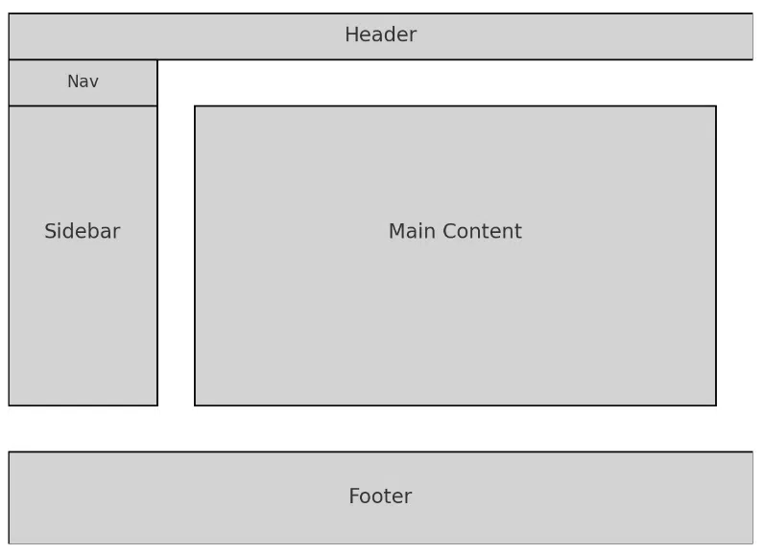

# 2. Assignment Objectives

In this assignment, you will:

* Use the **Visual Studio Code** to Create a React Project using Vite template.
* Analyze the master page and convert it into components.
* Run the project and test the BE interactions.

# 3. Database Design

A part of News Management Database:

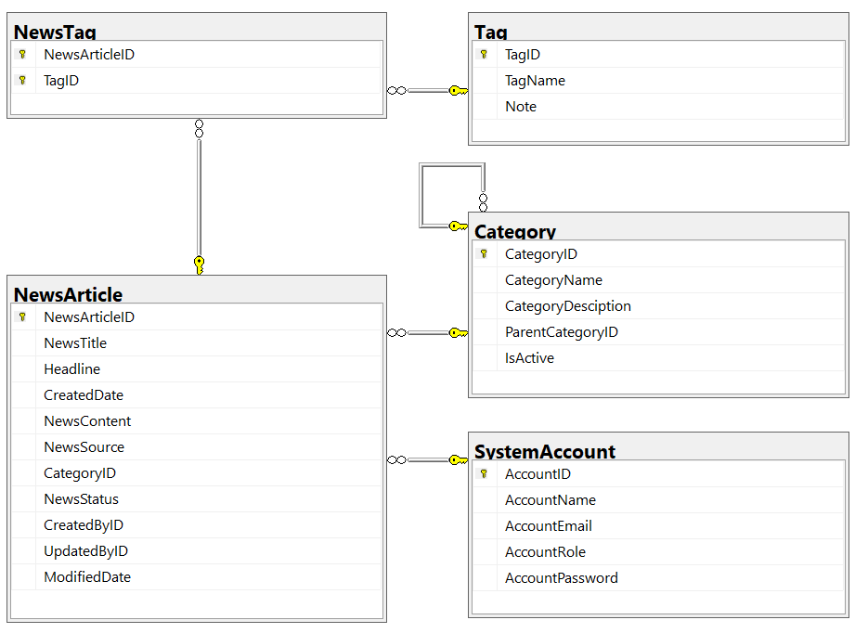

* A news article will belong to only one news category (Category).
* An account with staff’s role can create many news articles in this system. (Admin role = 1, Staff role = 2).
* A news article will have many tags and one tag will belong to zero or one news article (News status = active(1)/inactive(0)).
* Category status = active(1)/inactive(0).

# 4. Main Functions

# Design a login page.

# Create a logo using AI generation.

# Develop a header component.

# Create menu components for the following sections:

# Dashboard

# Category

# News

# Users

# Settings

# User authentication:

# If the user is an “Admin” and the password is “Admin”, redirect the user to the admin page.

# Admin page functionalities:

# News Article Management, Account Management, and Category Management must include the following actions:

# Read, Create, Update, Delete, and Search.

# Create and Update actions should be performed via a popup dialog.

# The Delete action should always include a confirmation prompt.

# 5. Note

* To do your FE program, you must use **ReactJS**.
* Create ReactJS Project named **StudentName_ClassCode**.